Chapter 15
Money, Interest Rates, and Exchange Rates

■ Chapter Organization
Money Defined: A Brief Review.
Money as a Medium of Exchange.
Money as a Unit of Account.
Money as a Store of Value.
What Is Money?
How the Money Supply Is Determined.
The Demand for Money by Individuals.
Expected Return.
Risk.
Liquidity.
Aggregate Money Demand.
The Equilibrium Interest Rate: The Interaction of Money Supply and Demand.
Equilibrium in the Money Market.
Interest Rates and the Money Supply.
Output and the Interest Rate.
The Money Supply and the Exchange Rate in the Short Run.
Linking Money, the Interest Rate, and the Exchange Rate.
U.S. Money Supply and the Dollar/Euro Exchange Rate.
Europe’s Money Supply and the Dollar/Euro Exchange Rate.
Money, the Price Level, and the Exchange Rate in the Long Run.
Money and Money Prices.
The Long-Run Effects of Money Supply Changes.
Empirical Evidence on Money Supplies and Price Levels.
Money and the Exchange Rate in the Long Run.
Inflation and Exchange Rate Dynamics.
Short-Run Price Rigidity versus Long-Run Price Flexibility.
Box: Money Supply Growth and Hyperinflation in Zimbabwe.
Permanent Money Supply Changes and the Exchange Rate.
Exchange Rate Overshooting.
Case Study: Can Higher Inflation Lead to Currency Appreciation? The Implications of Inflation Targeting.

Summary

■ Chapter Overview
This chapter combines the foreign-exchange market model of the previous chapter with an analysis of the demand for and supply of money to provide a more complete analysis of exchange rate determination in the short run. The chapter also introduces the concept of the long-run neutrality of money, which allows an examination of exchange rate dynamics. These elements are brought together at the end of the chapter in a model of exchange rate overshooting.
The chapter begins by reviewing the roles played by money. Money supply is determined by the central bank; for a given price level, the central bank’s choice of a nominal money supply determines the real money supply. An aggregate demand function for real money balances is motivated and presented. Money-market equilibrium—the equality of real money demand and the supply of real money balances—determines the equilibrium interest rate.
A familiar diagram portraying money-market equilibrium is combined with the interest rate parity diagram presented in the previous chapter to give a simple model of monetary influences on exchange rate determination. The domestic interest rate, determined in the domestic money market, affects the exchange rate through the interest parity mechanism. Thus, an increase in domestic money supply leads to a fall in the domestic interest rate. The home currency depreciates until its expected future appreciation is large enough to equate expected returns on interest-bearing assets denominated in domestic currency and in foreign currency. A contraction in the money supply leads to an exchange rate appreciation through a similar argument. Throughout this part of the chapter, the expected future exchange rate is still regarded as fixed.
The analysis is then extended to incorporate the dynamics of long-run adjustment to monetary changes. The long run is defined as the equilibrium that would be maintained after all wages and prices fully adjusted to their market-clearing levels. Thus, the long-run analysis is based on the long-run neutrality of money: All else being equal, a permanent increase in the money supply affects only the general price level—and not interest rates, relative prices, or real output—in the long run. Money prices, including, importantly, the money prices of foreign currencies, move in the long run in proportion to any change in the money supply’s level. Thus, an increase in the money supply, for example, ultimately results in a proportional exchange rate depreciation. The link between money supply growth, inflation, and exchange rates is highlighted with a case study on the recent hyperinflation in Zimbabwe. Rampant money supply growth led to prices in Zimbabwe doubling nearly every day at the peak of the hyperinflation and only ended when Zimbabwe legalized the use of foreign currencies for domestic transactions. However, the reintroduction of a Zimbabwean currency in 2016 has led to renewed high inflation in the country as the Zimbabwe government has returned to expanding the money supply to finance deficits. A similar dynamic is playing out in Venezuela, which is experiencing high rates of inflation in tandem with rapid growth in the money supply.
The combination of these long-run effects with the short-run static model allows consideration of exchange rate dynamics. In particular, the long-run results are suggestive of how long-run exchange rate expectations change after permanent money-supply changes. One dynamic result that emerges from this model is exchange rate overshooting in response to a change in the money supply. For example, a permanent money-supply expansion leads to expectations of a proportional long-run currency depreciation. Foreign-exchange market equilibrium requires an initial depreciation of the currency large enough to equate expected returns on foreign and domestic bonds. But because the domestic interest rate falls in the short run, the currency must actually depreciate beyond (and thus overshoot) its new expected long-run level in the short run to maintain interest parity. As domestic prices rise and M/P falls, the interest rate returns to its previous level and the exchange rate falls (appreciates) back to its long-run level, higher than the starting point, but not as high as the initial reaction.
The chapter concludes with a useful case study that helps bridge the gap between the stylized world of the model and the real world of central bank policy making where the central bank sets the interest rate rather than money and news about inflation may change expectations about future money supply changes when the central bank has committed to a particular level of inflation.

■ Answers to Textbook Problems

1. A reduction in the home money demand causes interest rates in the home country to fall from Rh,1 to Rh,2. With no change in expectations, there will be a depreciation of the home currency from E1 to E2 as investors shift their savings into higher-interest-paying foreign assets.

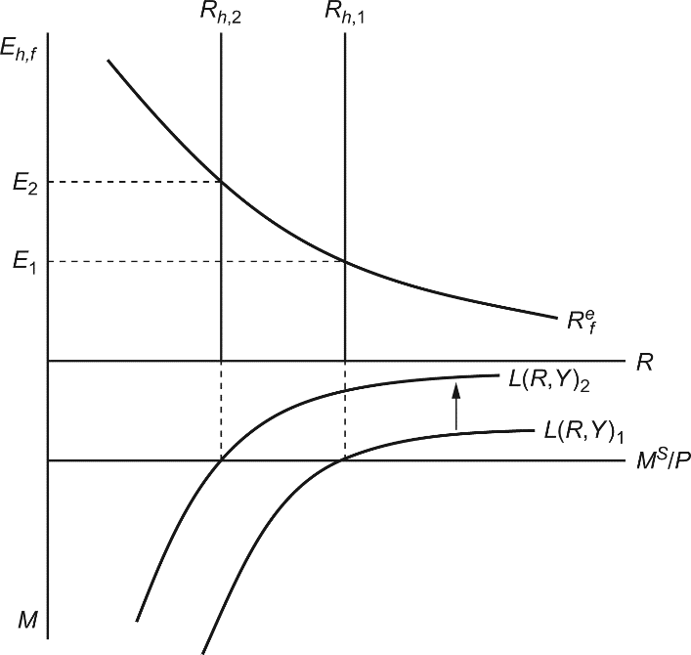
In the long run, increased spending on home products (through lower interest rates and a depreciated currency) will cause prices in the home country to rise. This will shift the real money supply inward to a point where home interest rates return to their original level R_{h,1} and the exchange rate falls back to E₁.
2. A fall in a country’s population would reduce money demand, all else being equal, because a smaller population would undertake fewer transactions and thus demand less money. This effect would probably be more pronounced if the fall in the population were due to a fall in the number of households rather than a fall in the average size of a household because a fall in the average size of households implies a population decline due to fewer children who have relatively small transactions demand for money compared to adults. The effect on the aggregate money demand function depends upon no change in income commensurate with the change in population—else, the change in income would serve as a proxy for the change in population with no effect on the aggregate money demand function.
3. Equation 15-4 is M^{s.}/P = L(R, Y). The velocity of money, V = Y/(M/P). Thus, when there is equilibrium in the money market such that money demand equals money supply, V = Y/L(R, Y). When R increases, L(R, Y) falls and thus velocity rises. When Y increases, L(R, Y) rises by a smaller amount (because the elasticity of aggregate money demand with respect to real output is less than one), and the fraction Y/L(R, Y) rises. Thus, velocity rises with either an increase in the interest rate or an increase in income. Because an increase in interest rates as well as an increase in income causes the exchange rate to appreciate, an increase in velocity is associated with an appreciation of the exchange rate.

4. An increase in domestic real GNP will cause domestic real money demand to rise. This will cause domestic real interest rates to rise from Rh,1 to Rh,2 (see graph below). With no change in expectations, there will be an appreciation of the home currency from E1 to E2 as investors channel their savings into domestic assets.

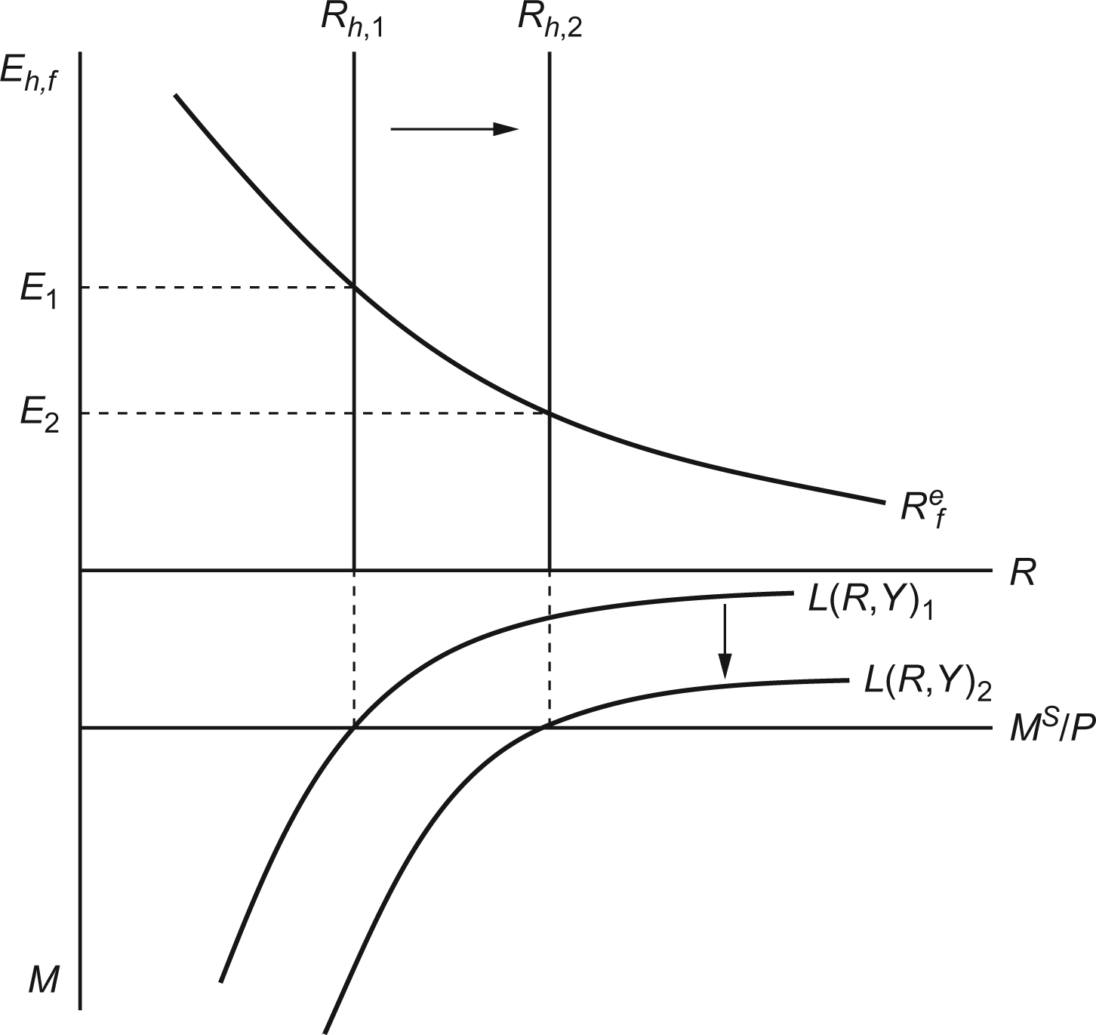
5. Just as money simplifies economic calculations within a country, use of a vehicle currency for international transactions reduces calculation costs. More importantly, the more currencies used in trade, the closer the trade becomes to barter because someone who receives payment in a currency she does not need must then sell it for a currency she needs. This process is much less costly when there is a ready market in which any nonvehicle currency can be traded against the vehicle currency, which then fulfills the role of a generally accepted medium of exchange.

6. Currency reforms are often instituted in conjunction with other policies that attempt to bring down the rate of inflation. There may be a psychological effect of introducing a new currency at the moment of an economic policy regime change, an effect that allows governments to begin with a “clean slate” and makes people reconsider their expectations concerning inflation. Experience shows, however, that such psychological effects cannot make a stabilization plan succeed if it is not backed up by concrete policies to reduce monetary growth.
7. a. As we would expect, the price level rises consistently with the increase in the Bolivian money supply. The long-run price level is defined as P = M^{S}/L(R,Y), so an increase in the money supply should cause prices to rise. An increase in the money supply and the price level should in turn cause the Bolivian peso to depreciate against the dollar. With a few exceptions (March 1985, for example), this is also occurring.
b. Between April 1984 and July 1985, the price level rose by 22,908%, while the exchange rate increased by 24,662%. Over this same period, the money supply increased by 17,434%. We should expect the price level and the exchange rate to move by the same proportion, as the value of the Bolivian peso is determined by its purchasing power (eroded by inflation). As the peso becomes less valuable, then its price relative to another currency (the dollar) should change by the same proportion. Interestingly, the price level and exchange rate change by a larger percentage than the money supply. This is also somewhat expected if we consider the equation for the long-run price level P = M^{S}/L(R,Y). Inflation will cause real money demand to fall, which causes prices to rise even further than that caused by the increase in the money supply alone.
c. The stabilization plan was effective at reducing the increase in the price level and arresting the depreciation of the Bolivian peso as supported by the price and exchange rate figures for September–October 1985. Interestingly, the money supply continued to grow (albeit at a reduced rate) during these two months. We can partially attribute the differential growth rates to expectations. If people believed the Bolivian government’s commitment to the stabilization plan, they would have revised their inflation and exchange rate expectations, causing the actual price and exchange rates to stop rising so quickly.

8. The charts below give inflation rates since 1980 for New Zealand, Chile, Canada, and Israel:
In every case (as well as for those countries not included in the chart above), inflation is significantly more stable after the adoption of inflation targeting.
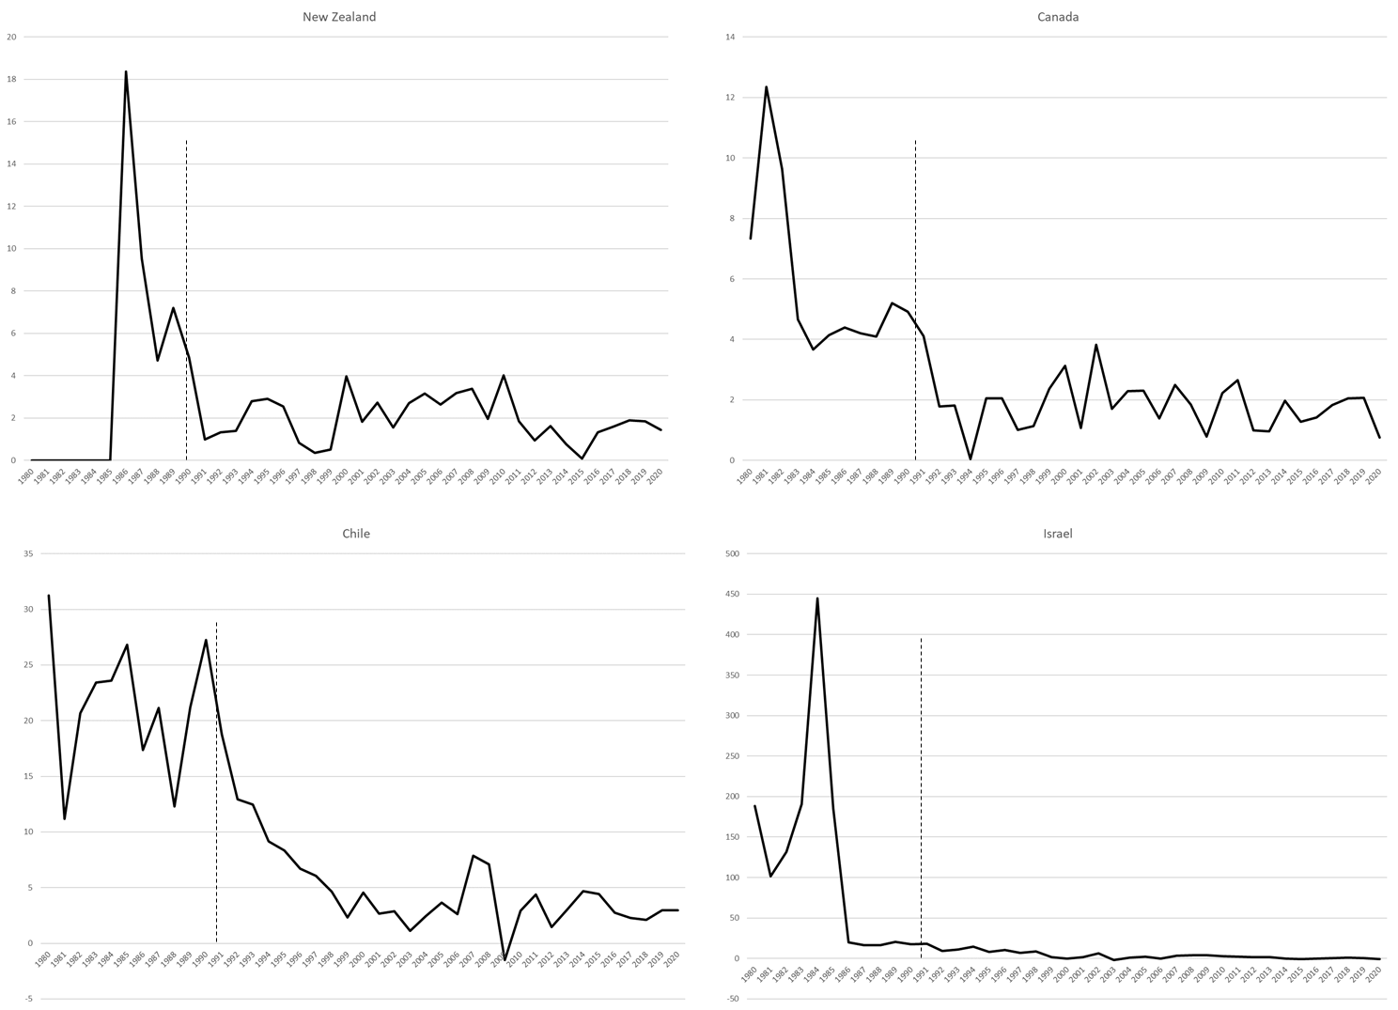

9. If an increase in the money supply induces an increase in real output in the short run, then the short-run decrease in the real interest rate will not be as pronounced as it was without the increase in real output. In the diagram below, the money supply rises from Ms.,1 to Ms.,2. This causes real output to rise from Y1 to Y2 and shifts the real money demand curve out from L(R, Y1) to L(R, Y2). In the diagram below, the resulting shifts lead to a reduction in interest rates from Rh,1 to Rh,2, which is a smaller drop in interest rates than would have prevailed had real money demand not shifted. (Note that it is possible that interest rates could have actually increased if the increase in real money demand was proportionately larger than the increase in nominal money supply. In this case, we will get exchange rate undershooting, with the short-run exchange rate below its long-run level.) Turning to the exchange rate diagram, two events occur. First, the drop in interest rates shifts the return on home assets from Rh,1 to Rh,2. Second, there is a change in expectations as people anticipate that the home currency will depreciate when home prices rise in the future. This shifts the expected return on foreign assets from to As a result of these shifts, the home currency depreciates from E1 to E2. However, the drop in the value of the home currency is not as severe as it would have been had output not increased (thus limiting the decrease in interest rates).

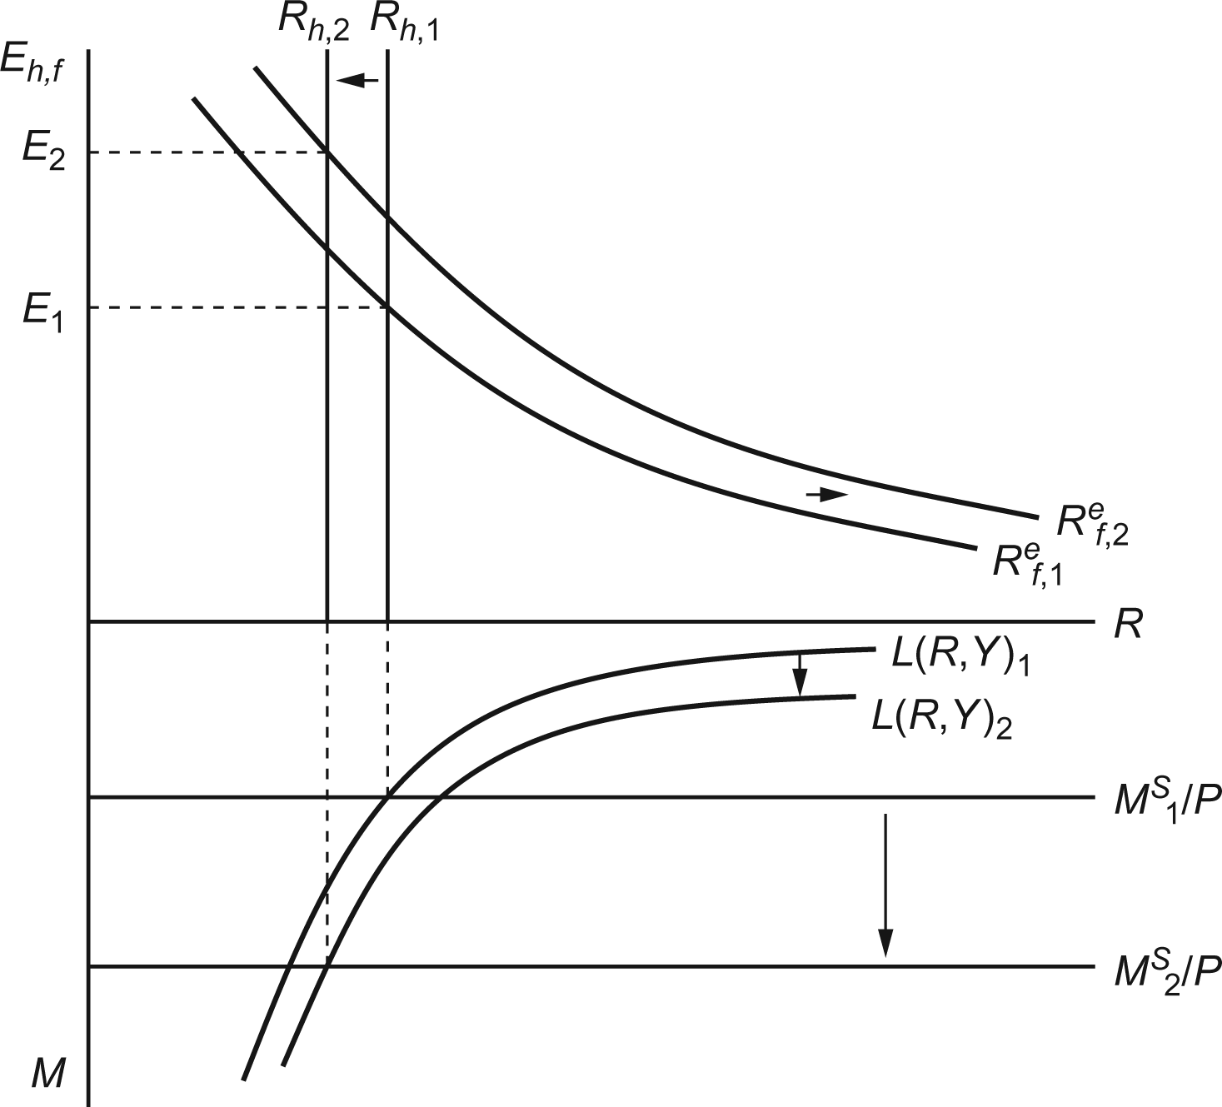
In the long run, prices in the home country will rise, shifting real money supply back to its original level and according to the text of the question, dropping output back to Y₁. This will cause interest rates to rise and, with no change in the expected return on foreign assets, cause the exchange rate to settle in at some value between E₁ and E₂. The extent of exchange rate overshooting is smaller in this scenario than when changes in the money supply have no effect on output because the change in output limits how large of an impact monetary policy has on real interest rates.
10. As the interest rate falls, people prefer to hold more cash and fewer financial assets. If interest rates were to fall below zero, people would strictly prefer cash to financial assets as the zero return on cash would dominate any negative return. Thus, interest rates cannot fall below zero because no one would hold a financial asset with a negative rate of return when another asset at a zero rate of return (cash) exists.
11. One clear complication that a zero interest rate introduces is that the central bank is “out of ammunition.” It literally cannot reduce interest rates any further and thus may struggle to respond to additional shocks that hit the economy over time. The central bank is still not completely powerless; it can print more money and try to increase inflation (increasing inflation with a constant zero interest rate would mean a declining real interest rate) to stimulate the economy, but the standard toolkit is not operational. As further discussion in Chapter 17 will show, a zero interest rate may also be a symptom of a lack of responsiveness in the economy to low interest rates.
12. a. If money adjusts automatically to changes in the price level, then any number of combinations of money and prices could satisfy the money supply/money demand equations. There would be no unique solution.
b. Yes, a rule such as this one would help anchor the price level and imply there is no longer an infinite number of money and price combinations that could satisfy money supply and money demand.
c. A one-time permanent unexpected fall in “u” would imply that R would have to fall until prices have a chance to rise and balance out the equation. As prices rise, R would return to its initial level. The story described is essentially identical to that in Figure 15-13. The interest rate would drop and then rise slowly over time, and the price level would start out static and then rise over time. The exchange rate should overshoot (assuming that expectations are tied to future prices in the same way they are described in the text).
13. Because Panama uses the US dollar as its currency, we would expect that, all else being equal, inflation in Panama and that in the United States should be identical. The chart below gives inflation rates in Panama and the United States over the past 20 years. On one hand, the inflation rates in the two countries tend to move together, as we would expect because they share the same money supply. In other words, an increase in the U.S. money supply should cause prices to rise in both Panama and the United States. That said, the inflation rates are not identical between the two countries. This is because prices (and thus inflation) are not determined by the money supply alone. Recall the long-run price level defined as P = M^{S}/L(R,Y). Although Panama and the United States share the same money supply, the demand for money in each country may differ, allowing for differences in price levels.
